TODAY’S LUNCH SPECIALS

Soup: Clam Chowder A PH favorite. This rich, cream-based soup is a blend of Atlantic clams,
potatoes, whitefish, vegetables and is a hearty delight.

Salad: Mixed Greens A plentiful selection of fresh mined greens fills the plate and is topped with
tomatoes, onions beets and carrots. Your choice of Italian, French, Blue Cheese,
Thousand Island, Vidalia, or Creamy Peppercorn dressing.

Entrée: Beef Tenderloin The beef is cooked to perfection! From rare to well done, this lovely cut of beef
is juicy and tender.

Entrée: Lemon Dill Salmon Salmon is always a big hit at PH. The light sauce is infused with a hint of dill.

Side Dish: Roasted Potatoes Wonderfully seasoned, the roasted potatoes are crispy on the outside and fork
perfect on the inside.

Vegetable: Sautéed Green Beans With just a bit of oil, the garden crisp beans offer a savory crunch.

Deli: Chicken Salad Sandwich Plenty of chicken mixed with just the right amount of mayo is tasty with
your choice of bread; white, wheat or rye. Then add your accoutrements of
tomatoes, lettuce and anything else you desire to make a perfect sandwich.

Desserts: Cheesecake New York Style and then some! A tall slice is richly thick and creamy.

Ice Cream: Mint Chip The perfect combination of cold, creamy mint ice cream and chocolate
chips within. Have it plain, with whipped cream or add chocolate sauce.

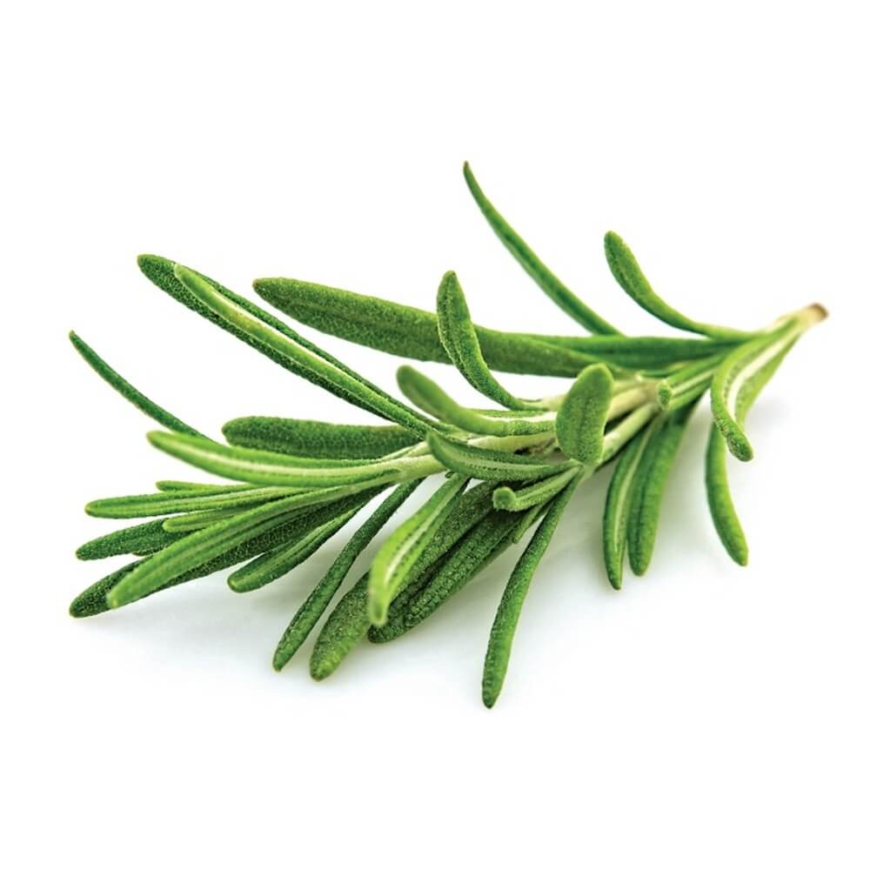
This Photo by Unknown Author is licensed under CC BY-NC
BEVERAGES:
Coffee: Regular & Decaf
Tea: Hot or Iced
Juices: Orange, Cranberry, Apple
Sodas: Ginger Ale, Diet Ginger Ale
Coke, Diet Coke
Milk: Regular or Lactaid

